Staffordshire University

School of Digital, Technologies and Arts

*BSc Computer Games Design*

Individual Games Technology Project (GAME60193):

Research & Development Report

Tori Miller – 20020115

**Contents**

Introduction 3

Outline of process 3

Developing the concept and considerations for app and device features 4

Preparing test documents and ethics 5

Planning for application systems 6

RFID/NFC & BLE 6

Unity NFC Reader Capability 7

Setting up the Unity Android project 10

Game manager & save/load data feature 11

UI design & implementation 12

Arduino microcontrollers & NFC capability 14

NFC modules for Arduino 15

Soldering electronic components 15

Troubleshooting NFC libraries for Arduino Nano 33 BLE 17

NFC tags and NDEF records 17

Device pedometer 18

Powering the device 21

Peripheral device casing design 23

Live testing & data collection 25

Conclusions / Reflection 28

Appendix 30

References 31

## Introduction

The basis for the project is to improve the relationship between a dog and their owner, using a mobile app that enables gameplay activities between the two subjects. The mobile application is planned to pair to a microcontroller device that attaches to the pet’s collar and tracks their activity in real-time. The objectives are to:

1. Learn to interface between microcontroller computers and game engines, to create new and intuitive experiences for players.
2. Improve the quality of life of pets and their owners, individually and together.
3. Learn to develop game engine projects for mobile phones and build them successfully.

To achieve each goal, access to the following will be required:

* A range of microcontrollers (Arduino or adjacent) with components that can facilitate connections and game input between the computer and mobile phone.
* A game engine that is RFID/NFC capable, with appropriate plugins.
* Pet owners willing to engage in tests to ensure the effectiveness and quality of the project, as well as display its potential as a tool to benefit its users.
* SDK/IDE programs for any mobile phone operating systems we are developing for.
* Photoshop, to create UI elements/graphics for the finished mobile phone app.

The approach that will be taken to solve problems is to cast a wide net and explore as many options as possible, for instance with RFID/NFC connection to find several plugins or scripts and investigate which achieves the objective in the shortest range of time. Through research and iteration, we will reach a result that is informed and likely to be the best suited method for this project.

## Outline of process

A device to be fitted on the neck of a pet (the core focus being on dogs) is to be planned, developed, iterated upon, and finalized using Arduino hardware. The purpose of the device is to gamify the activity between the pet and its owner to improve their relationship, as well as the pet’s health and wellbeing. Research will take place to meet animal welfare standards. A Unity Engine mobile phone application that communicates with the device will monitor and track the duo’s progress as they play together and provide meaningful feedback to the pet owner to keep them engaged in the long-term with their pet.

The project will conclude with a finalized prototype collar peripheral, mobile phone application, supporting documentation in the form of a Git repository ‘README’ file (including game design & technical design documents, schematics, etc.) and a final reflection. Bugs and quality of life issues will be kept to a minimum through conscientious user testing at several stages of development.

## Developing the concept and considerations for app and device features

The concept is to provide a method of co-operative play between an owner and their pet (in the case of this project, a dog) using a game application and peripheral device, to provide enjoyment and potentially improve the relationship between the two subjects. Due to the impose time constraints, the project will be designed around one core feature: steps tracking for the pet. This will help to prevent over scoping and ensure outcomes are met.

The mobile application will be developed using Unity Engine 2021 LTS (Long Term Support) due to its adaptability for mobile development over Unreal Engine (that being for wearables applications), as well as being the most recent stable build of the engine as of 2022/2023. The game engine was notably used for the development of Pokémon GO (*Niantic, 2016*), where managing virtual pets and GPS features are the main USPs. This can suggest the engine’s appropriateness for the development of similar mobile phone applications. The company Fitbit previously had the Fitbit Studio SDK (*Fitbit, 2015*), which could be used to create applications to use in tandem with their range of devices, though as of April 2023 has been deprecated.

The app will make use of the user's phone to log their pet's steps and gamify the activity. The visual style is influenced by the clear and distinctive shapes and colours found in Nintendo and Sanrio’s products. This is for both readability and to ensure the aesthetic of Companions Plus (the project application) does not read as professional or to be trusted as a veterinary guideline, otherwise gaining the user's trust with their pet's medical care could become problematic. Staging the app and device as a toy that allows the user to play with their pet, with the goal being the improvement of the pet's wellbeing and relationship with owner may be more appropriate.

Application features may include:

* 'Idle Mode' - The default state of the app when not in use. Happiness and Level can rise or fall. This state is set when tagging back from Walk Mode.
* 'Walk Mode' - The owner tags the device with their phone while the app is open. The device begins to count the pet's steps.
* 'Rest Mode' - Based on studies for how often a dog should be walked. The app will be disabled for 24 hours after too many steps.
* 'Photo Mode' - Photos can be taken via the app and are bundled with the week's step data. This can be viewed in the Activity Log.
* 'Activity Log' - A weekly calendar, complete with graphs to show the rise and fall of step data week-by-week. Photos from Photo Mode are also displayed.
* 'Milestones' - Viewable in the Activity Log. Graphs will glow brighter and brighter on consecutive days with optimum steps achieved. Boosts levelling up.
* 'Help Guide' - A brief tutorial animation on how to use the device with the app and explaining the app's features.
* 'Step Data' - The steps walked in a day is shown on the home screen, while compiled weekly and monthly data is displayed in the Activity Log.
* 'Pet Avatar' - An animated dog silhouette with the pet's name assigned, alongside the pet's level. Tapping will cause a random animation to play.
* 'Pet Name' - Assigned on the first launch of the app.
* 'Pet Level' - A long-term stat to represent time spent playing the app together with the owner's pet. Can decrease with lack of use.
* 'Happiness' - A short-term stat to represent the frequency of activity with the owner's pet. Will begin to fall through lack of use.

These features will be included in the repository README file alongside technical documentation (schematics, systems diagrams).

The peripheral device will need to be able to communicate directly with the mobile phone application, so components should be considered for this. Using Arduino microcontrollers will provide the greatest amount of freedom during the project since they are purpose-fit for hardware prototyping. Using Arduino in conjunction with BLE (Bluetooth Low-Energy) or RFID/NFC are optimal approaches to setting data between the devices. These communication methods will be explored later in the project.

## Preparing test documents and ethics

It should aim to encourage and award the owner and dog in an ethical way. As such, animal welfare research should be considered to prevent distress or upset to those involved in the use of the application and peripheral device. The wellbeing of the animal will be measured based on the paper 'Development and initial validation of a dog quality of life instrument' (*Geert De Meyer et al, 2022*), which suggests studying physical, emotional, and social aspects of the animal at several points in time.

A questionnaire using Likert scaling is to be created to be able to devise a numeric representation of the pet’s wellbeing at the beginning and conclusion of testing. The sample size should range from between 5 and 10 pairings of test participants to obtain more accurate data. It is important for participants to also fill the form once before beginning a test to provide a baseline to compare against.

## Planning for application systems

Based on the previously specified application features, a breakdown of the systems present in the Unity application was created, alongside a simple mock-up of the application’s visuals which includes buttons for each feature. Attention was brought towards the game manager’s individual states, functions (see <https://www.w3schools.com/c/c_functions.php> for further explanation on creating and calling functions) and variables.

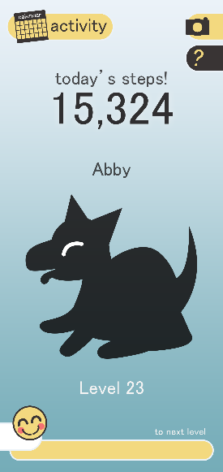 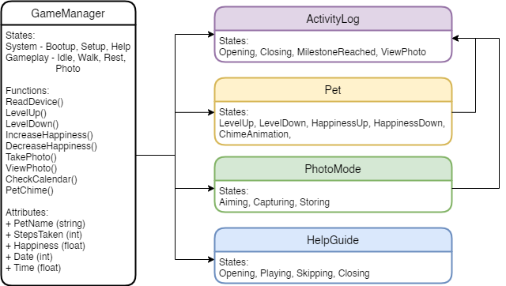

New UI elements created when buttons are pressed should be able to communicate the game manager directly, so references to the game manager will be set in their individual C# scripts as required.

## RFID/NFC & BLE

Comparisons were made between RFIC/NFC and BLE to determine which is the most suitable.

|  |  |
| --- | --- |
| **RFID/NFC Advantages** | **BLE Advantages** |
| No power source needed for NFC tags.  Inexpensive technology. | Long operating range (>10m).  Larger data bandwidth than NFC. |
| **RFID/NFC Disadvantages** | **BLE Disadvantages** |
| Short operating range (<10cm).  Deprecated in many mainstream devices. | Power source always required.  Device pairing with phones required. |

*(Cited from González, 2014 and Gold, 2020)*

Due to the affordability and availability of both passive and active NFC communication, it will be a better fit over BLE for the project. NFC’s closeness may be an advantage to the design of the project as it requires the user to be physically closer to their dog to use the peripheral.

## Unity NFC Reader Capability

An NFC Reader plugin for an older 2017 version of Unity was found on GitHub, with an MIT license that permits full, free use (*Twisprite, 2017*). It is now unsupported and has issues with using a legacy GUI implementation method, so the code was modified to add in the ‘UnityEngine.UI’ namespace. Furthermore, by attaching the plugin to the project application's UI buttons instead of writing UI elements using C# scripts, making later changes to the application’s visuals will become a less involved process, since the positions of game objects can be moved from the details panel in Unity. The app is unable to build on computers that do not have the Java Development Kit, Android SDK/NDK Tool and Gradle installed. Having these SDKs installed is essential for all Unity Android development, not only for this specific plugin and should be considered when the Unity project is created.

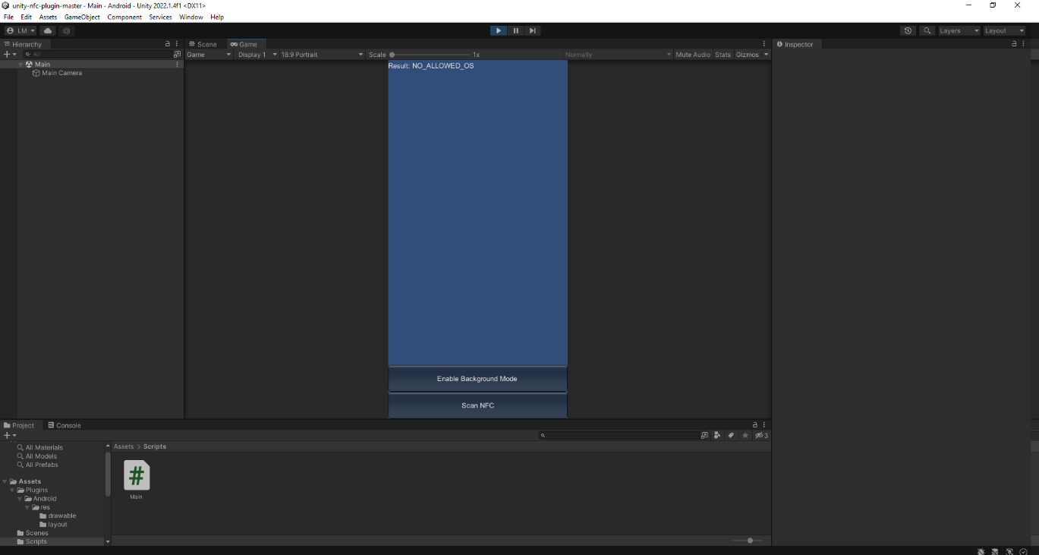

The Twisprite plugin found online had several issues when attempting to use it, including obsolete engine tools and the lack of ability to read directly from a resources folder containing all Android related files, as well as the app crashing when running on an Android mobile. Attempts were made to update the code and package Android files so that they can be read in Unity 2021 LTS, but further issues became apparent such as debug log errors referring to deprecated engine features. The choice to use this plugin was reconsidered and other open-source plugins were searched for online.

Another project on GitHub (*Geske, 2019*) was found, which also contained a build of the application for testing. After installing a build onto an Android mobile phone, the application read both student card and banking card NFC tags and displayed them as a string of characters. The documentation mentions the project is not capable of writing data to NFC tags, only reading NFC tags. The Arduino peripheral device will be used to handle all device logic, so NFC writing functionality from the application will not be needed. When loading the project into Unity, the same errors were received as with the previous NFC plugin. With the knowledge that the application can at the very minimum read NFC unlike the former, troubleshooting the plugin was attempted.

On reading Unity forums threads, several developers were encountering the same error as encountered here (as mentioned above). Others had suggested to pack the Android resources into an Android Archive (AAR) or Android Library Project, and that this would fix this error. On the official Unity Support website, the same solution is recommended. Further reading into creating an AAR for the current NFC Unity project was undertaken. One user suggested adding '.androidlib' to the name of the Android folder in projects to force Unity to treat the folder as a Gradle module.

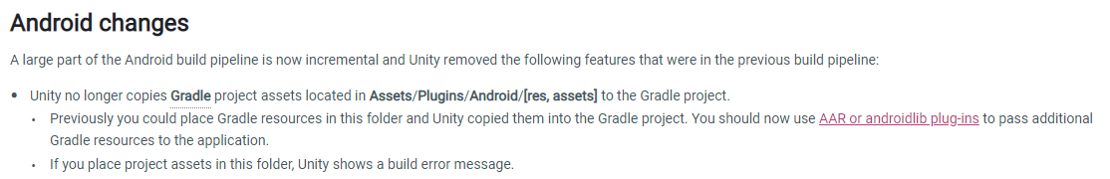

(*Unity – Manual: Upgrading to Unity 2021 - Android Changes, 2021)*

After the findings, research will be conducted on how to compile the Android resources folder inside the project into an AAR or Android Library for use with newer versions of Unity. Additionally, the Unity Store will be searched for NFC read-write plugins in case the previous method does not fix this with the project.

After tweaking build settings, updating the project to a more recent version of Unity Engine was successful, and Android plugin files are handled differently. The problem consisted of newer versions of Unity Engine now have unityLibrary modules built in for Android development, while the older project contained conflicting information in several of its files, such as the AndroidManifest file. By checking 'Custom Main Manifest' and 'Custom Gradle Properties Template', duplicate data was omitted (*Unity – Manual:* *Android player settings 2021*).

The second issue consisted of not using a keystore, or it not being correct, which has been said to prevent some Android projects from building (*Unity - Manual: Create a new keystore, 2021*) (*Unity Forums, 2022*). In conclusion the screen scaling and UI canvas settings in the Main.unity scene were reworked to fit all screen aspect ratios appropriately rather than creating a letterboxing effect.

After addressing these issues, the app built correctly. Both the 2017 and updated new LTS version of the plugin were installed onto a mobile running Android 12 (the app can run on devices from Android 5.1 upwards) and were tested with a student card to ensure they had the same outcome. The next step was to create a project with interactive UI that checks for the student card's NFC data and reacts on scanning.

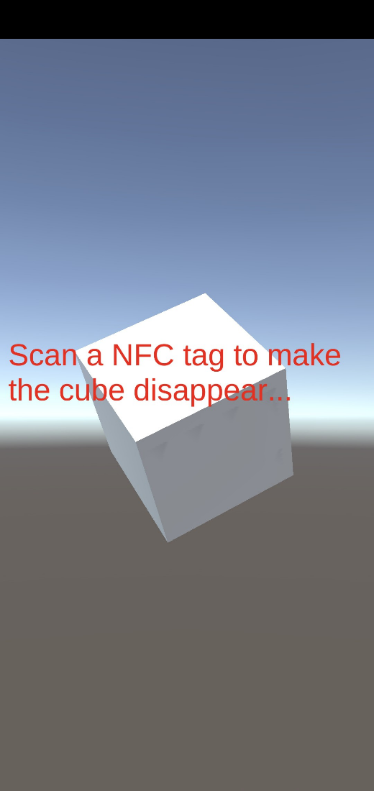 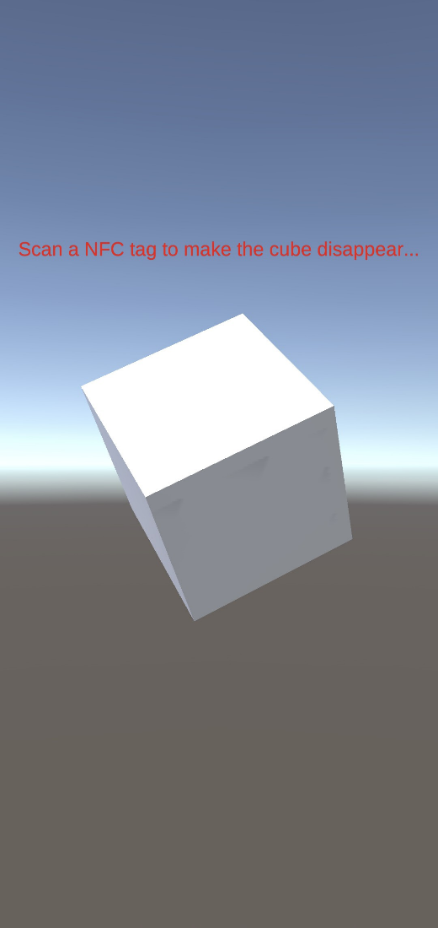

The updated Unity 2021 LTS version of Christophe Geske’s Unity 2017 NFC plugin was made available on GitHub as a fork of their original repository (self-published *- Near-Field-Communication-NFC-For-Unity-Android, 2022).*

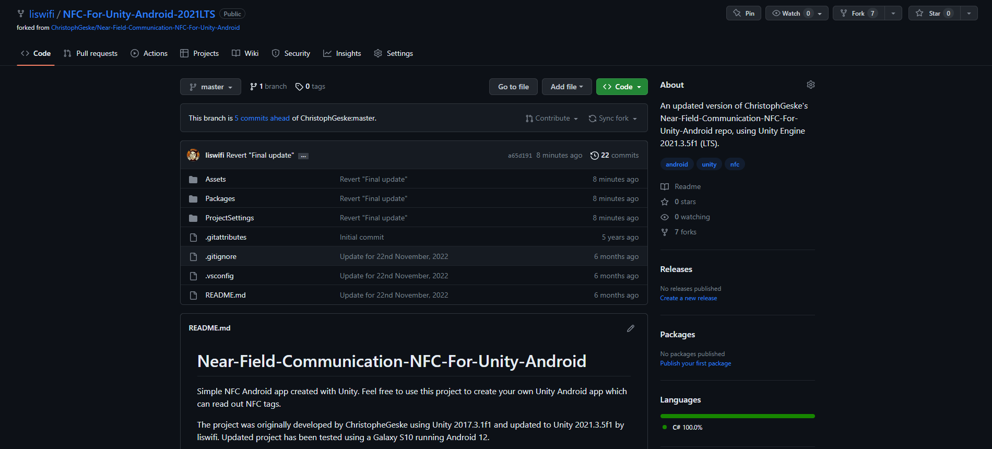

With the NFC plugin and game design concepts completed, the next step is to repeat the process of creating a new Unity Android project, importing the 2021 version of the NFC plugin, and generating graphics and audio for the project application.

## Setting up the Unity Android project

A new project is set up using ‘2D Core’ as a starting template. This is suited for both Windows/OSX and Android, to allow for testing within Unity Engine and on Android phones.

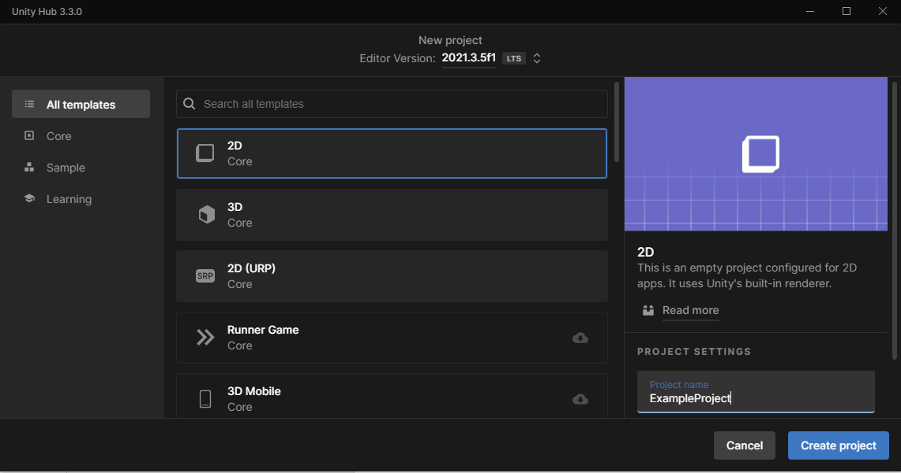

From here, the new 2021 LTS plugin is imported into the root project folder and additional folders are created for meshes, textures, animations, scenes (3D environment which game objects are loaded into) and C# scripts. SDKs for Android and Microsoft’s Visual Studio IDE were additionally installed to facilitate the scripting and building of the application.

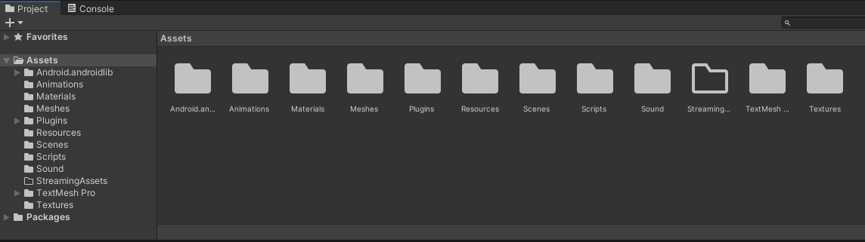

A keystore was created for the publishing of the application and the project was uploaded to GitHub as a new repository. This allows for rollbacks of development through multiple iterations, referred to as a commit. The application had been developed with user accessibility in mind, the lowest possible Target API Level was chosen for building the application. With the NFC plugin being developed originally using Android 7.1 from 2016, using previous versions could have potentially compromised its functionality.

## Game manager & save/load data feature

The initial pseudocode draft of the C# script for the game manager was coded based on the previous system diagram, using functions to set the application’s variables. Features like printing NFC tag data to a UI text field were initially delegated to the NFC plugin script but would consequently use the game manager script as a reference and send the tag data to it directly. This allowed for the triggering of sounds and updating variables at the same time. This data was saved on recording from the tag and loaded again on every open of the application. Audio was created using the DAW (Digital Audio Workstation) FL Studio 20 and exported as .WAV files as they are uncompressed and provide high quality sound.

A game development tutorial channel on YouTube, Brackeys (*YouTube, 2018*), has a guide on saving and loading in Unity in which variables are serialized into binary and saved to a file on a device the application is running on. This save data file can then be deserialized back into the original variables and processed as needed. It is important that any variables that are serialized are either public or using the [SerializeField] attribute (which can also be used to expose private variables in the details panel in Unity) as specified in Unity’s documentation (*Script Serialization - Unity, 2021*). A separate script from the game manager script holds all variables for saving, therefore any behaviors that do not need to be saved are omitted from the process.

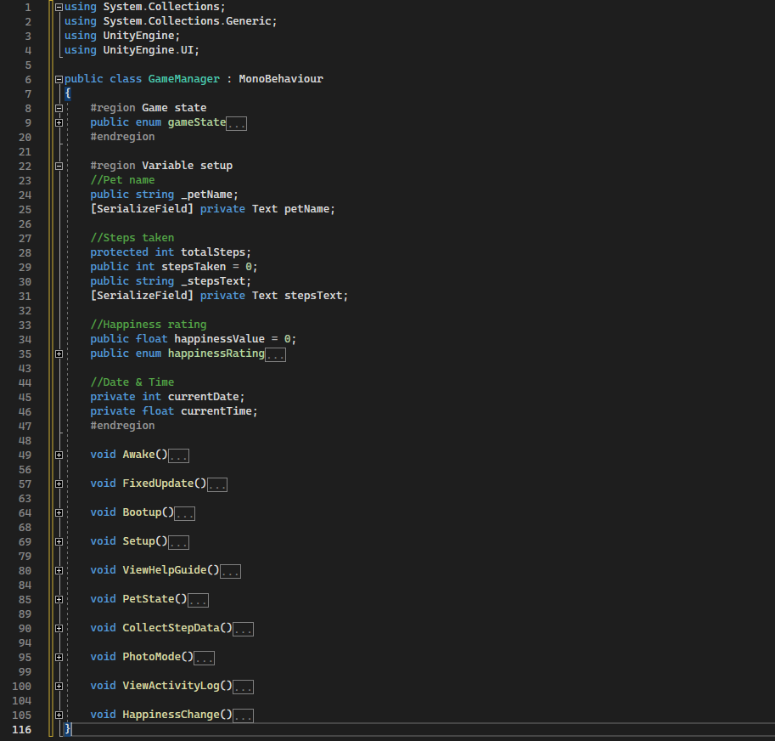 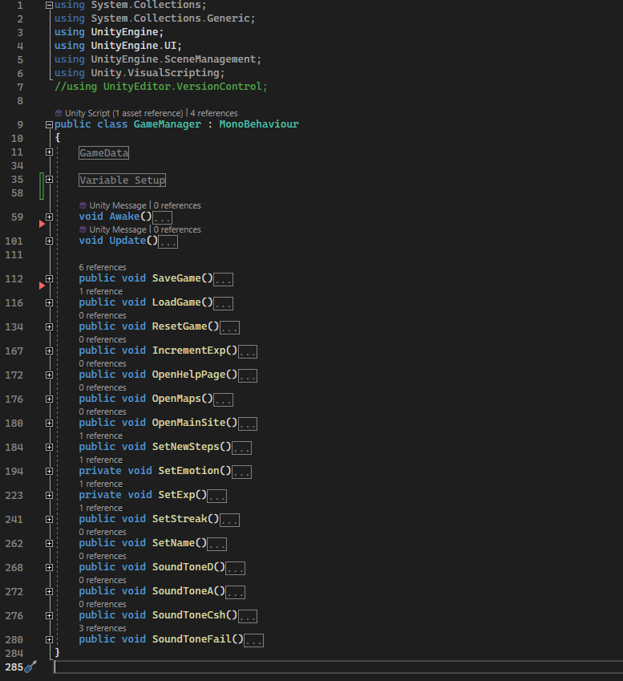  
*Pseudocode game manager (left) and finalized game manager (right).*

The game states were removed from the game manager since their inclusion became arbitrary later in development - the physical act of scanning an NFC tag and updating the game manager’s data would happen simultaneously and other buttons presses became inconsequential to the state the game was in (being that they only opened external URLs).

The initial concept for the experience points feature was to create a deeper system like the levelling systems present in contemporary RPGs. Needing to incentivize players to engage with the core of the gameplay, the feature became simpler and directly tied the total steps taken using the application to the experience points and level of the user’s real-world dog. If more time were available to focus on the project, a CSV (comma-separated values) file would have been used to allow easy balancing tweaking for the rate users can ‘level up’. Due to this constraint, levelling happens at an exponential rate by using a simple incrementing formula. Steps can only be submitted to the application once per day by tracking the Android mobile’s current date against the ‘last played’ time. This will help mitigate the possibility that application users may prioritize the application over the wellbeing of their dog to gain experience points.

## UI design & implementation

A few methods were considered when planning the UI, including importing individual UI assets and packing them down into a single texture. Inspiration was taken from Super Nintendo (~1990) sprite sheets when packing the UI together to keep the project files tidy. An official Unity tutorial (*Manual: Sprite Atlas Workflow – Unity, 2021*) explains how to pack and use UI assets in a sprite atlas, a type of texture atlas (another name for packed textures). Parts of the UI plan .PSD document were copied into a new 1024px document and either redrawn or polished, then placed into islands of relevant graphics. A gradient and non-gradient version was produced; however, the non-gradient's flat colour presentation is in line with contemporary mobile apps.

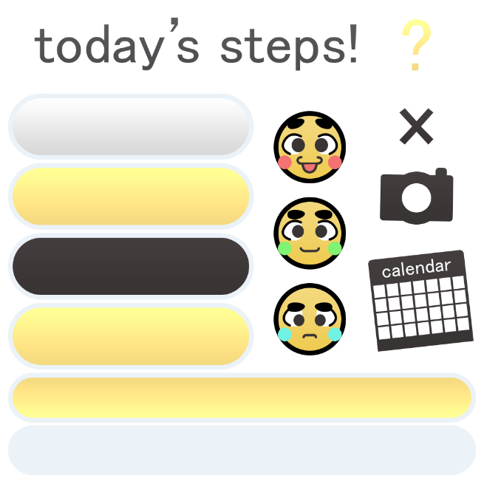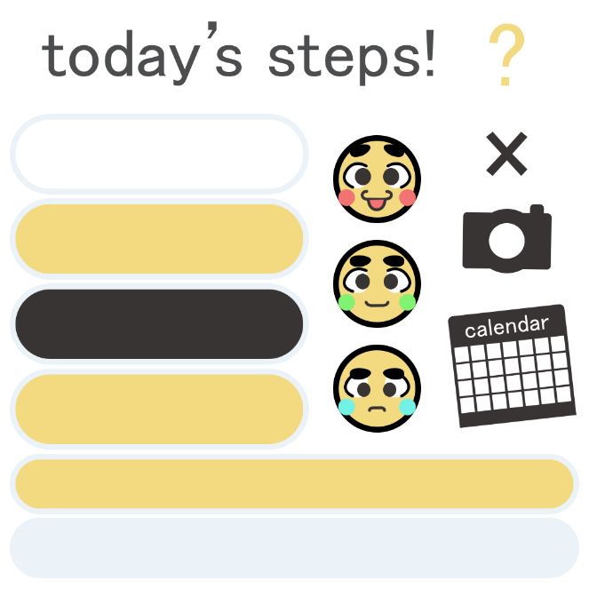

Simple functionality was attached to each graphic in the form of UI buttons. The camera button will open the Android mobile's camera but does not include access to the user’s photo gallery to store captured photos. As a possible stretch goal, captured photos will be stored within the Activity Log, attached to a scatter plot graph to represent each week. The Activity Log menu is not intended for the scope of the project. The Activity, Guide and Emotion UI elements correlate to increasing experience points for debugging purposes (which increases the bottom level meter, up to 100% filled), as well as to the Save/Load feature. To test that all features worked as intended, the application was installed on two individual Android phones to ensure that saved data could be recovered by pressing the button that loads previous data.

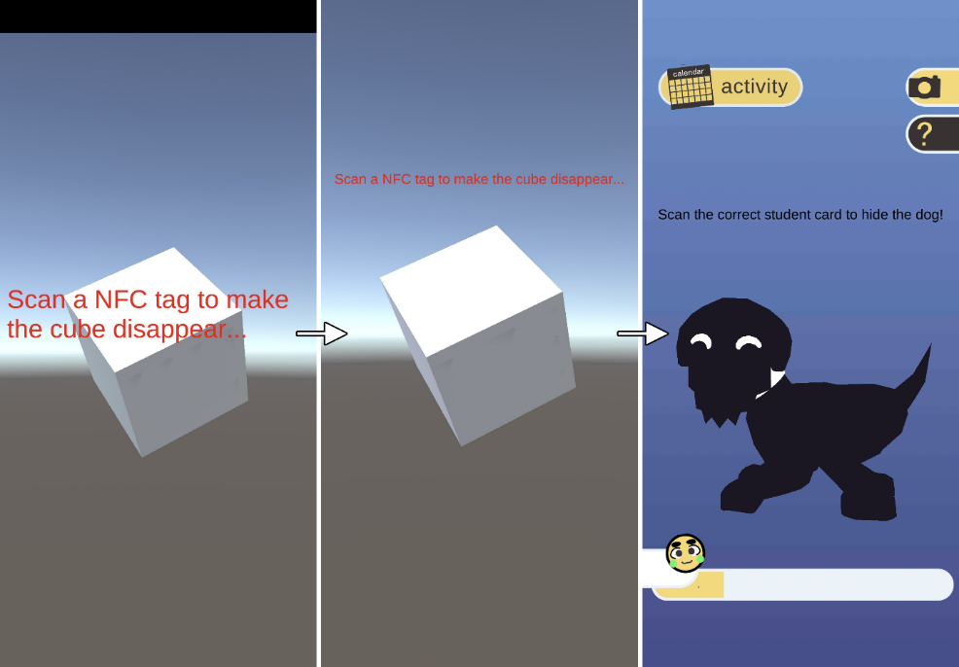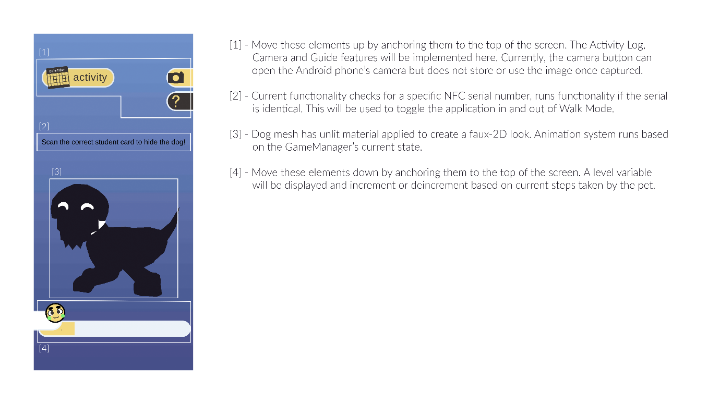  
*The application as 2017 NFC Reader, 2021 LTS version, prototype application and final build.*

UI elements will be readjusted, and existing functionality will be iterated upon as features are added or removed throughout development. Unlit materials were applied to the dog mesh to match the aesthetic of the flat UI graphics. There was an intention to create several sets of animations for this mesh (idle, resting and walking game states, for when the player taps the dog), though due to being out of scope this was omitted from the project altogether, alongside the activity log and photo gallery features. In its place, a utilities hot bar to allow users to access maps (*Unity Answers – Open Google Maps with address in Unity, 2016*) and their camera from within the application was added. The NFC feature caused the dog mesh to disappear once a tag was scanned, as proof that it was possible to check against the UID (Unique Identifier) and cause specific functionality to occur. This was to be iterated upon once a prototype of the peripheral device was functional.

## Arduino microcontrollers & NFC capability

A mock-up of the required components was made on beginning the research into microcontrollers and NFC technology. It was important that the device was light weight enough and had a small enough form factor to fit comfortable around the collars of a broad range of dog breeds.

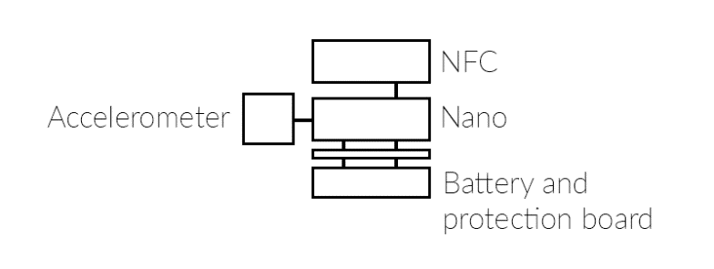

The initial prototype for the device was based on the Arduino Nano BLE microcontroller due to its 45x18mm size, compared to the other much larger boards that Arduino offer. The Nano BLE range is specified to also allow NFC connections through its Nordic Semiconductors nRF52840 processor (*Arduino Store – Arduino Nano 33 BLE, 2019*) in conjunction with the on-board BLE module (*Arduino – u-blox NINA B3 Series Datasheet*), however it is not available as a ready-to-use feature. The microcontroller (Nano BLE) shows two pins that are purpose-fit for connection with an NFC antenna, which would require creating a library to control its functionality (*GitHub – Gerriko, Nano 33 BLE NFC Driver, 2022*). Using a pre-existing library with an NFC module is recommended. This is disadvantageous since it increases the form factor of the device, although it is unavoidable as NFC features are necessary to the project.

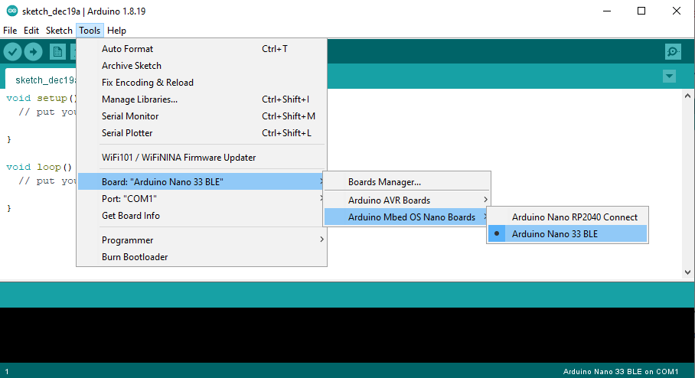

The Arduino Nano BLE range of devices were designed for ‘wearables’ prototypes and contains an IMU (Inertial Measurement Unit), used to track rotations and acceleration to act as a pedometer, making it viable for this project as a method of tracking steps.

## NFC modules for Arduino

Several modules are available which use the RC522 and PN532 NFC chips developed by NXP. The section below shows a comparison between these chips.

|  |  |
| --- | --- |
| **RC522 Advantages** | **PN532 Advantages** |
| Cost effective.  Several power-saving modes. | DIP switch to select interface mode.  Supports more protocols. |
| **RC522 Disadvantages** | **PN532 Disadvantages** |
| Working distance is less than 50mm.  Only supports ISO14443A protocol. | Working distance can be greater than 50mm.  ISO14443B only supported in ‘reader mode’. |

*(Seeed - Nicho, RFID/NFC/MiFare chip selection guide, 2020)*

The versatility of the PN532 module over the RC522 module makes it an appropriate candidate for this project. Adafruit’s PN532 NFC controller breakout board features its own code library (*GitHub – Adafruit-PN532, 2023*) with examples of reading and writing NFC tags, albeit is much larger than the Arduino Nano BLE microcontroller itself and does not support card emulation. Several other PN532 modules have publicly available libraries based on Adafruit’s own, for example Seeed (*GitHub – PN532, 2020*) and Elechouse (*GitHub – PN532, 2018*), both of which have stated to support other PN532-based modules and feature NFC card/tag emulation.

## Soldering electronic components

Elechouse’s module was purchased alongside the Arduino Nano 33 BLE Sense REV2, the former of which had no attached header pins (metal pins allowing users to easily prototype jumper wires were used to connect the appropriate pins, before soldering each pin together for rigidity). Right-angled header pins were soldered onto the PN532 module for a slimmer form factor than would be possible with straight header pins.

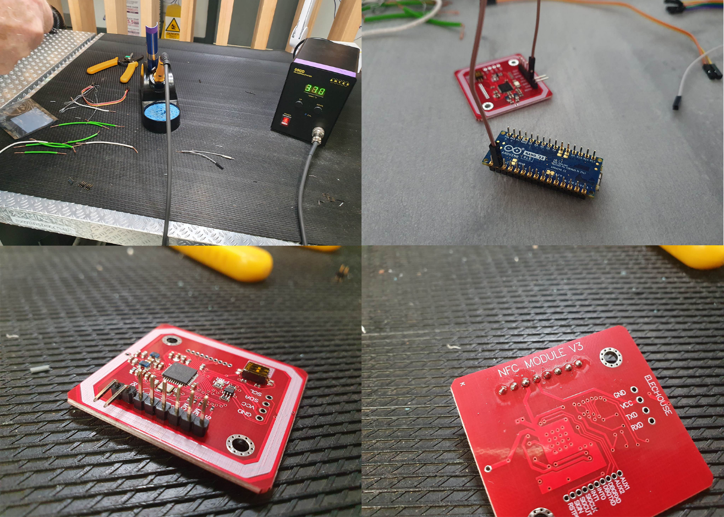

All components were later soldered together and powered using USB via a computer for reading NFC scan results from the Arduino IDE serial monitor. It is vital that each connection (wire or solder) on the microcontroller do not touch to prevent shorting circuits (in the case that excessive electrical current is passed to a pin) or preventing proper functionality in the device. Heat shrink tubing is used to protect each connection for this purpose.

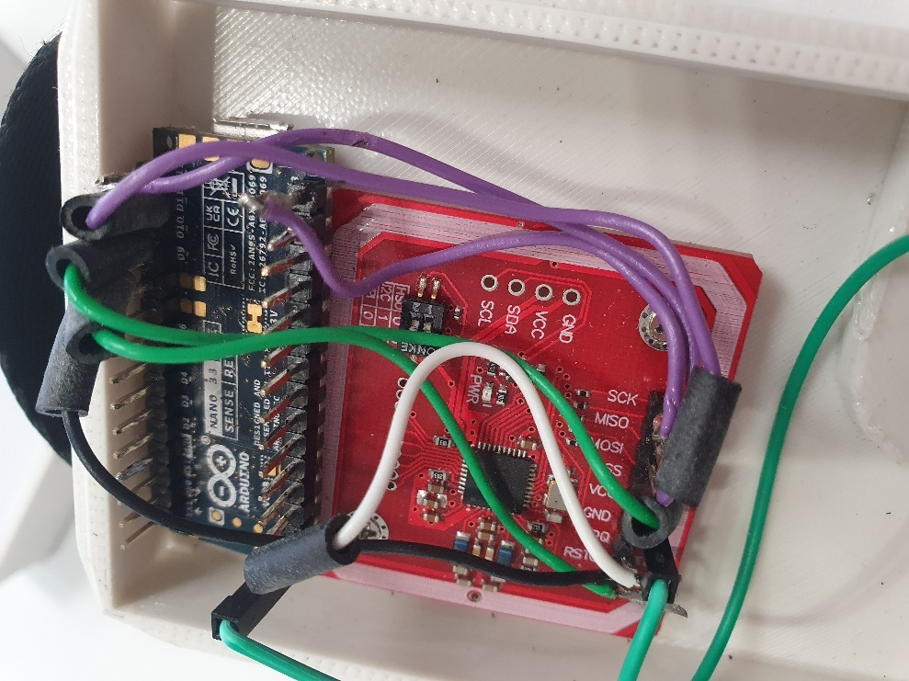

The Nano 33 BLE is connected to the PN532 module via SPI interface, in accordance with the Arduino documentation on SPI (*Arduino Docs – Nano 33 BLE Sense Rev2 Cheat Sheet*). This was presumed to enable virtual card/tag emulation on the device, allowing the transfer of game data from the device to the mobile phone. The PN532 Elechouse library is stated to work with the Arm Mbed OS platform for Arduino microprocessors, which is installed on the Nano 33 BLE range.

## Troubleshooting NFC libraries for Arduino Nano 33 BLE

When using the Elechouse library’s example sketch for tag emulation (emulate_tag_ndef.ino), nothing was printed to the serial monitor in Arduino IDE (a window used for reading debug messages while connected to a computer), nor was the Android phone using in testing receiving an NFC signal from the device. Errors in the IDE compiler (below image) where incorrect variables were used was corrected, but the issues persisted. This was found to have been due to the lack of a secure element on the NFC chip itself, which Adafruit explains on their FAQ for the PN532 module: “it's impossible to implement since it requires an external 'secure element' that is very difficult to source…” (*Adafruit Learn – PN532 FAQ*). Additionally, the derivative libraries (Seeed and Elechouse) were unable to compile for Arduino Nano 33 BLE due to a lack of a coding standards (*Codacy – Coding standards: what they are, and why do you need them, 2022*), leading to contradictions and incompatibilities with some Arduino boards. The original Adafruit library does follow coding standards, meaning code is written efficiently, with consistency across files and minimal bugs.

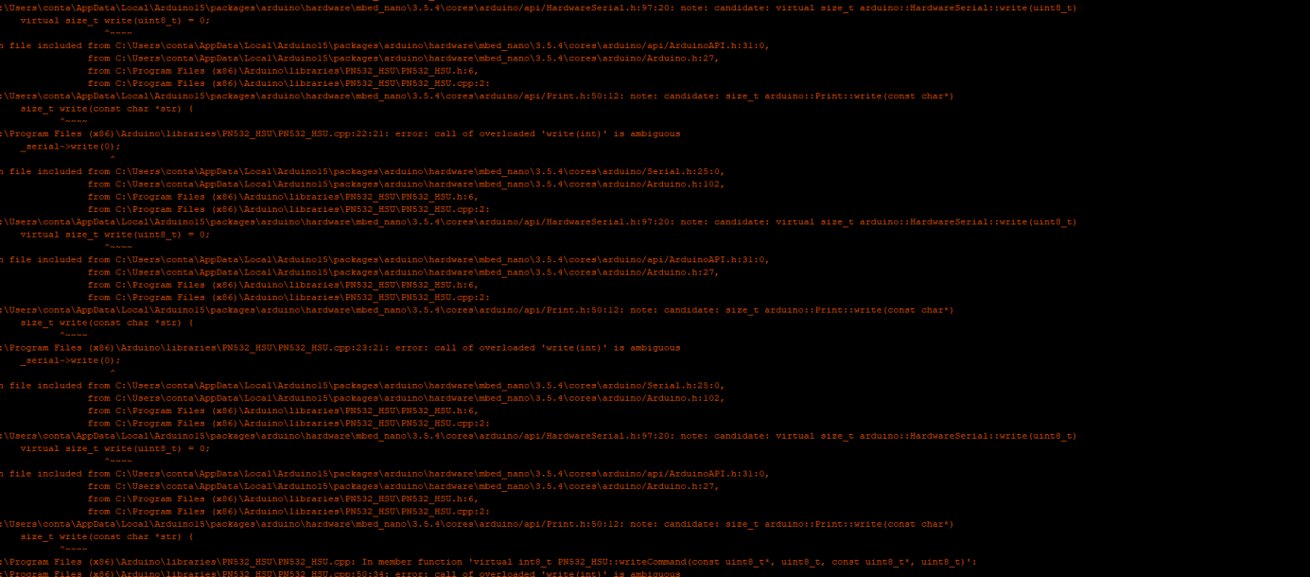

## NFC tags and NDEF records

The time spent attempting to emulate NFC tags during the project, left a narrow window at the end to produce a functional device to work with the already developed application. Host Card Emulation to emulate a tag from the Android phone (*Android Developer – Host-based card emulation*) may have been a viable solution; however, it cannot be explored within the given timescale. PN532 boards are designed to work with ISO14443 NFC tags and can be used as a proxy between the device and game application to transfer step data. This has disadvantages, such as the game card data not being up to date with the device or application and potentially causing disruption to the ordinary progress within the game application. The device should read the game card data and add it to its own, then rewrite the game card with the new data value. By doing this, all logic relating to game card data is kept between the two components rather than across three and will hopefully lessen the margin for error.

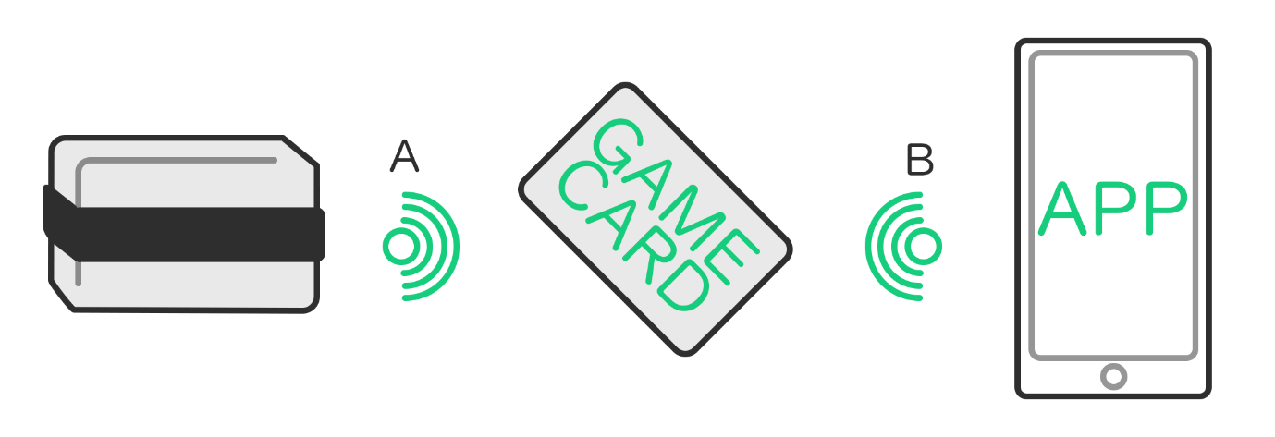 *A: Device reads GAME CARD for game data, add to device game data, rewrite GAME CARD with new game data value. B: Phone reads GAME CARD for game data, adds to game application game data total and daily steps.*

NDEF messages are blocks of information that exist in each ‘sector’ of an NFC tag’s data. Adafruit’s library contains the example sketch ‘mifareclassic_updatendef.ino’, which can be used to write NDEF messages to sector 1 on a MiFare Classic NFC tag formatted for NDEF. The function ‘mifareclassic_WriteNDEFURI’ has three arguments (values received by function) for the sector index (by default set to 1), the NDEF record’s URI prefix (*GoToTags – NDEF Record Type*) and the URI (NDEF message data) to set in the chosen sector. To begin testing, the URI was set as the string of characters “Steps taken!” and read by an Android mobile by using the free-use Android application ‘NXP TagInfo’. Once it was confirmed that the data was written to the NFC tag, the pedometer feature of the device was focused on in order to write step data to the same URI at runtime.

## Device pedometer

The Arduino Nano 33 BLE Sense has capabilities as a pedometer by using the BMI270 IMU’s included library (*GitHub – Arduino_BMI270_BMM150*, 2023), via either the received 3-axis (X, Y, Z) accelerometer data or 3-axis (X, Y, Z) gyroscope data. The first approach was to modify the example sketch for accelerometer data by adding a sensitivity value and to increment a ‘steps’ integer by one for every accelerometer value that exceeded the sensitivity value. By tweaking the sensitivity value, the level of force required to add one step to the step counter would increase or decrease.

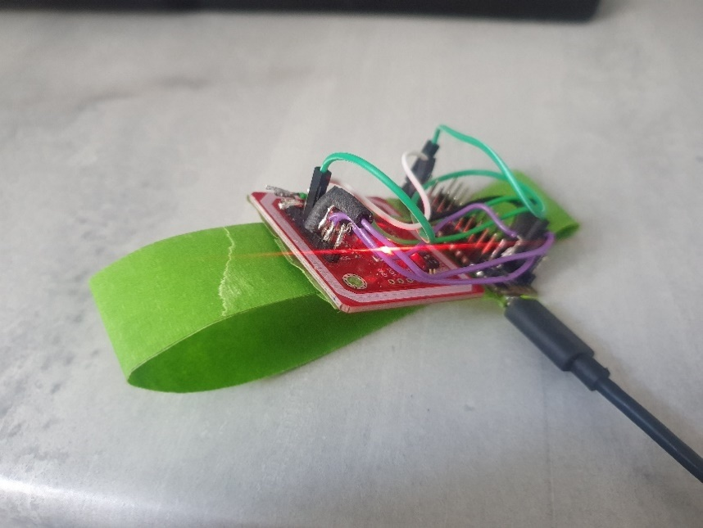

The accelerometer of the Sense Rev2 was observed to have been dramatically more sensitive when compared to the Sense Rev1, while the Rev2’s gyroscope behaved similarly to the Rev1’s accelerometer instead, despite a gyroscope being based upon the angular velocity of a device and not its linear acceleration (*Analog Devices - Accelerometer and Gyroscopes Sensors: Operation, Sensing, and Applications, 2014*). The accelerometer was supplemented by the gyroscope sketch and provided much more reliable results when wearing the device attached to an improvised wristband, which was later replaced by a basic 3D printed casing (modelled using 3DS Max 2023) once all components were measured.

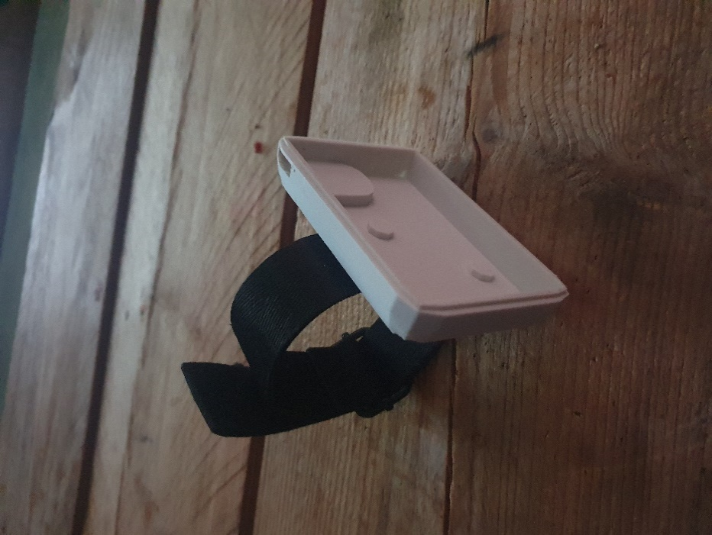 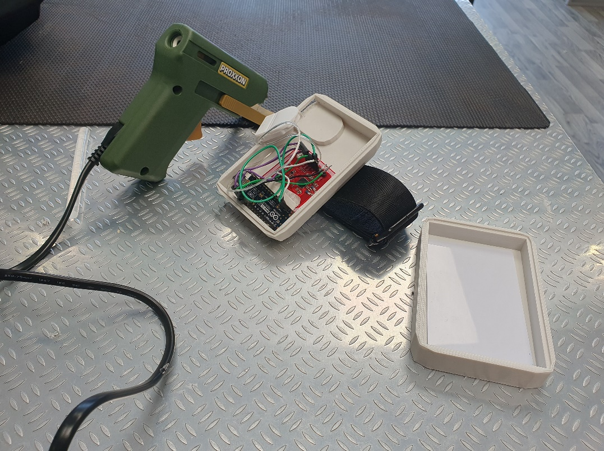

The modified gyroscope code was added into the finalized code for the device, and converted from an integer (whole number value) to a string using the ‘itoa()’ function and creating an array of characters (numbers, letters or symbols) called buffer. The URI/URL for the NDEF message is then set to this buffer value, allowing for the NDEF data to be updated at runtime.

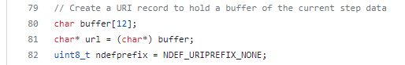



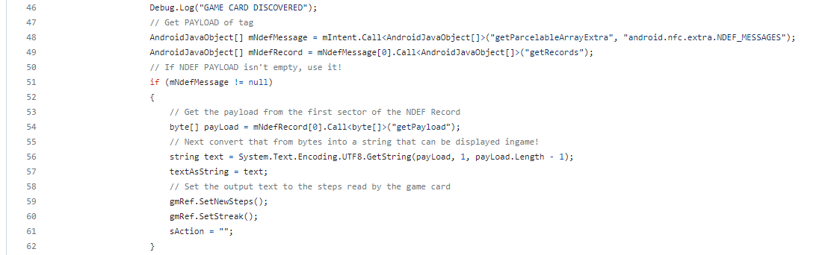

Data in NDEF records is stored as bytes and needs to be converted back to a string or integer when received by the Unity Android application. If the game card data detected by the application contained an NDEF message, the payload read from the game card would be stored to an array of bytes, encoded as a UTF-8 string (*Hubspot – What is UTF-8 Encoding?, 2021*) and lastly stored in the NFC script as a new variable (*Unity Answers – Base64 encode/decoding?, 2010*). The game manager was then able to access the updated ‘todaySteps’ string variable and convert it to a whole number to display using Microsoft’s .NET framework function ‘TryParse()’ (*Microsoft – Int32.TryParse Method*).

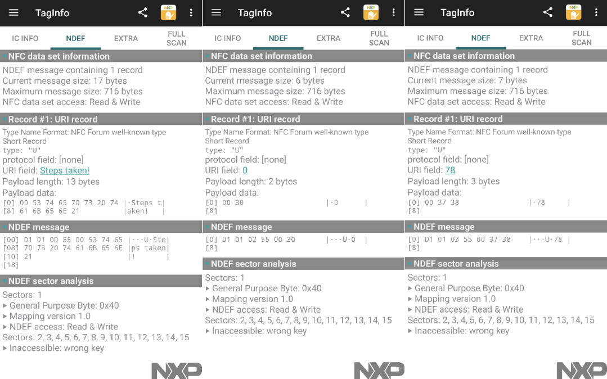

*NXP TagInfo NDEF data for string of characters, default steps taken, and final steps taken.*

## Powering the device

As a wearable device appropriate for attaching to a dog collar, it was important that it was lightweight and would need to be recharged or have batteries replaced as infrequently as possible. Schematics diagrams were created on initial soldering and later when choosing batteries for the peripheral device to help visualizing the device internals.

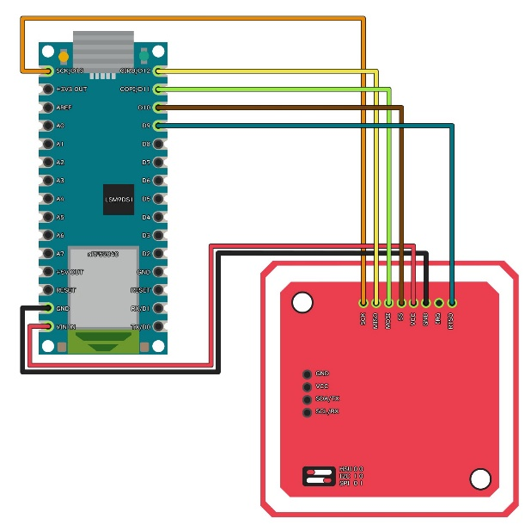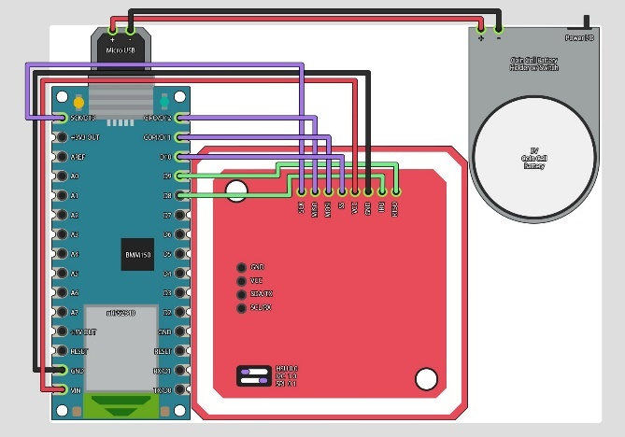

Battery considerations at this point in the project included:

* 3V CR2032 lithium coin batteries (in series to create 6V in or parallel connection to provide 3V to the device at a greater current)
* Rechargeable lithium polymer – Lightweight with greater energy density
* USB to Micro USB battery for portable devices
* Standard 9V alkaline battery

(*Information sourced from Electronics Hub – ‘How To Power Arduino Nano With Battery’*)

A lithium-ion or cell (watch) battery was planned to be used to power the device due to its compact size and light weight – this is the optimal approach, considering it could then be worn by smaller dog breeds. If using a lithium-ion battery, a battery protection board must be used to protect from either damage to the battery, device or pet that could be wearing it (potential fire hazard, electric shock, or chemical burn). After experimenting with 3V lithium coin batteries, it was found that 6V required power to be regulated and 3V did not provide enough current for proper functioning of the Arduino Nano, which runs at 3.3V.

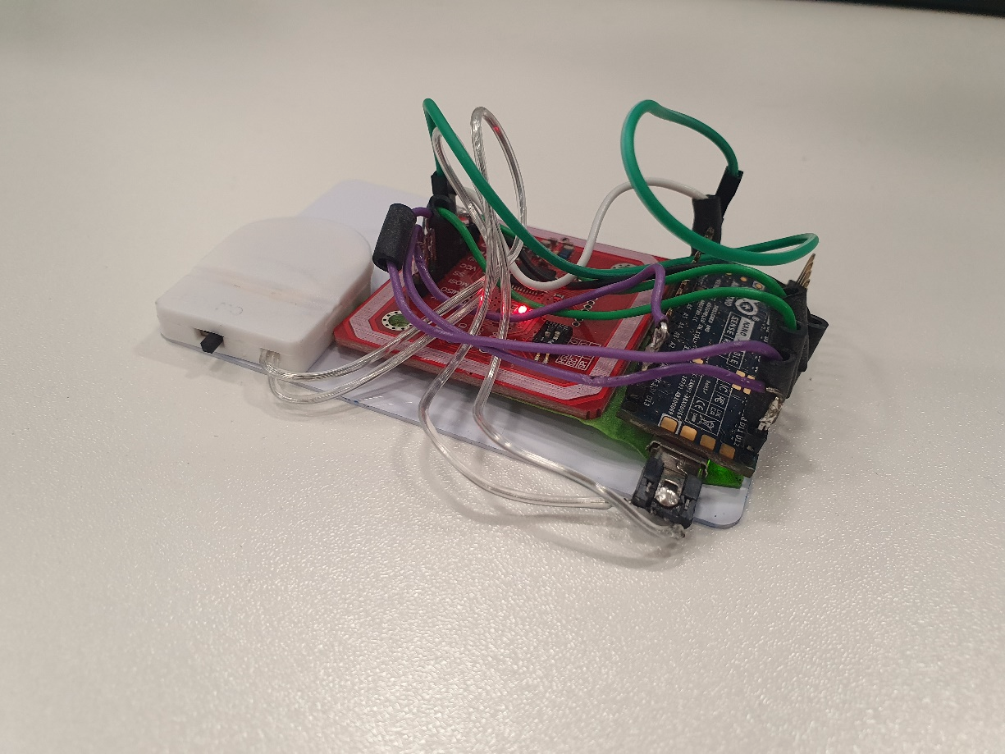

The USB to Micro USB battery was ultimately chosen since the VIN pin of the Arduino Nano was in use by the PN532 module and adding a power supply at this pin could have damaged the module or microcontroller by providing too much power. The VUSB port on the microcontroller regulates the power input as required without the need of a battery protection board or battery holder. 5V 2A USB power from a portable power bank was used in place of externally regulated power to the microcontroller via the VIN pin (*Arduino - Powering Alternatives for Arduino Boards, 2023*). The weight of the power bank makes the device unsuitable for usage with small dog breeds.

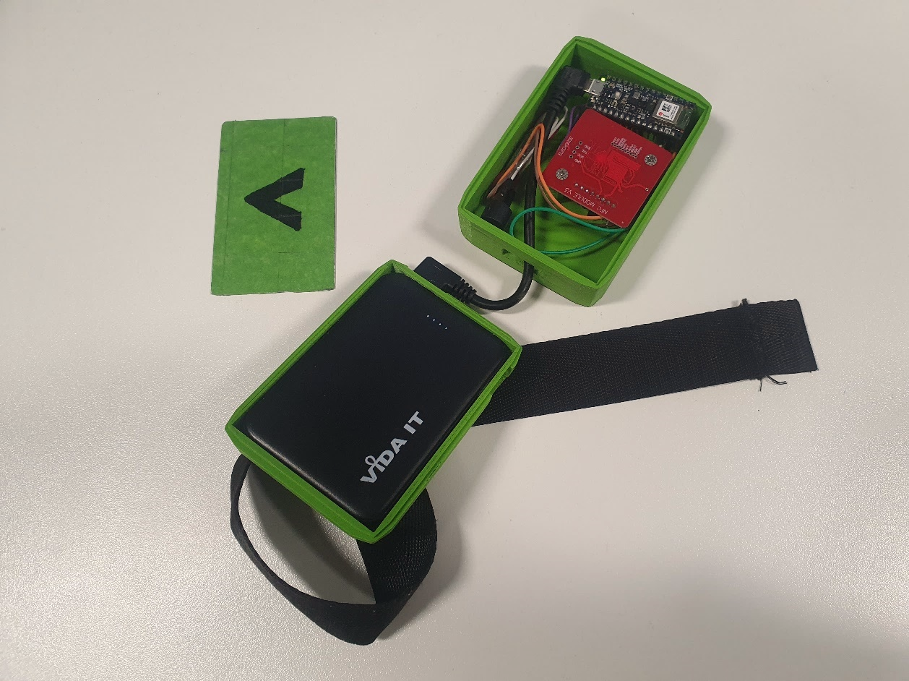

## Peripheral device casing design

Device measurements were taken from the technical specifications for the microcontroller and module during earlier, less informed designs. Later designs were planned after measuring the components and looking to teardowns of the contemporary Pokéwalker device (*Hackaday, Reverse Engineering a Pokéwalker, 2020*) and medical device Freestyle Libre. The latter is a continuous blood glucose reading device created by Abbott Laboratories. It makes use of SPI and i2c communication together to send data to an RF430FRL152H RF transponder (*Texas Instruments, NFC Transponder datasheet*). When being scanned by another device, its passive NFC chip emits its own signal to send medical information (*YouTube - Freestyle Libre Sensor Teardown and Inside Analysis*).

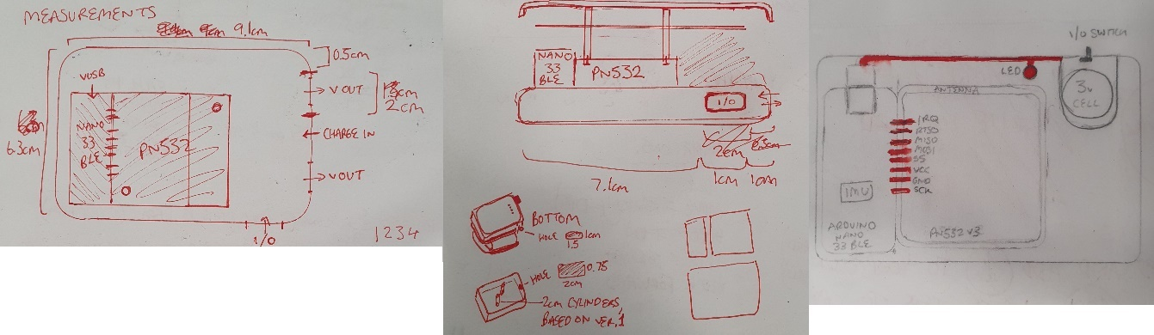

There was no room for batteries or any NFC module in the casing’s first iteration, while the second iteration had more room for additional batteries, however the wiring was exposed if the shell was opened which presents the risk that the user may cause damage to internals when needing to swap batteries. The final iteration housed the components in the upper half of the casing with wiring concealed on top. The distance between the PN532 module and top of the device prevents consistent NFC tag reading or writing. The poor signal is also capable of preventing the card from being formatted for NDEF messages correctly, causing the card to become unreadable in the Unity application. Replacing the straight header pins of the microcontroller with right-angled header pins would have enabled a slimmer design and prevent most interruptions when attempting to write to the game card.

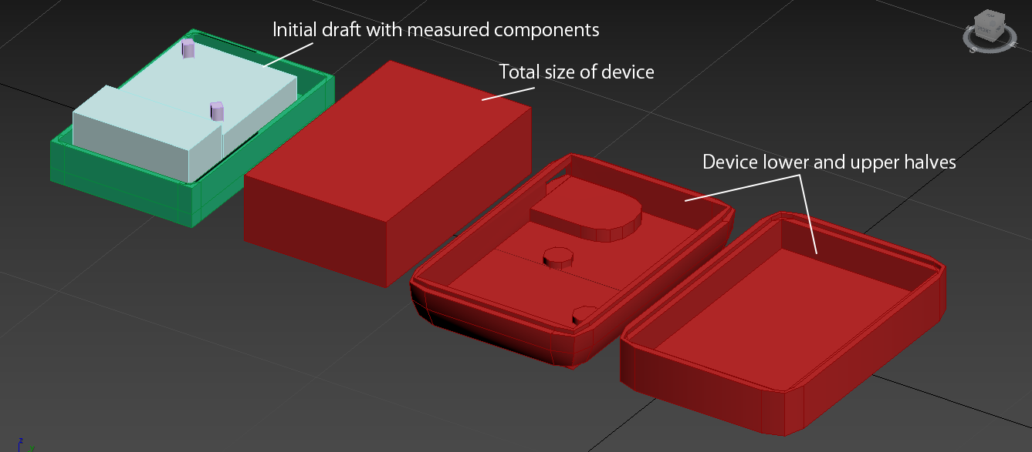

The casing was printed using PLA, or polylactic acid, due to its affordability and ability to recycle as a biodegradable material (*Biopak – What is PLA, 2022*). The NXP Mifare Classic cards have read/write cycles (how often data can be read or written on the card before it effectively breaks), which is seen to be at 200,000 on the card's datasheet (*NXP – MiFare Q&A, 2015*). The cards used with the device are third-party and may have less read/write cycles as a result, so the decision to make the card easily replaceable when designing the device casing is to be considered.

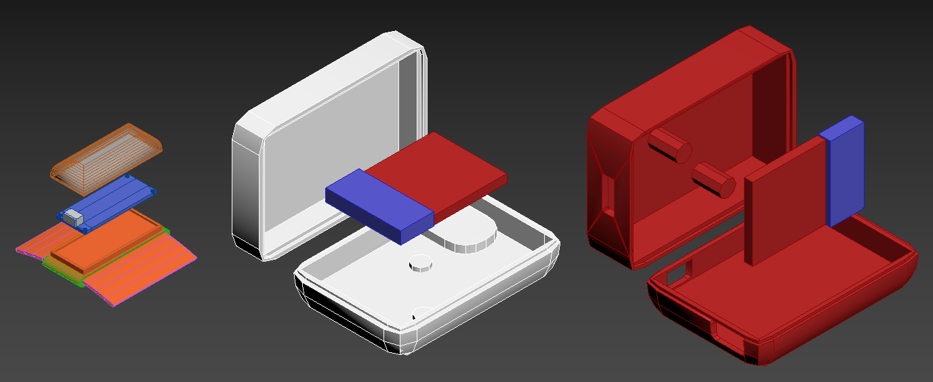

The game card was concealed in the shell of the second iteration to test if the card could remain inside of the device to act as an alternative to tag emulation, however the signal from the PN532 module blocked the testing Android phone’s NFC reading capabilities. The game card is to be coupled with the peripheral device during use and placed over the marked area to record step data for reading with the application. There is no clear indicator that the device is operational, so a piezo buzzer or LED must be fitted to signal this.

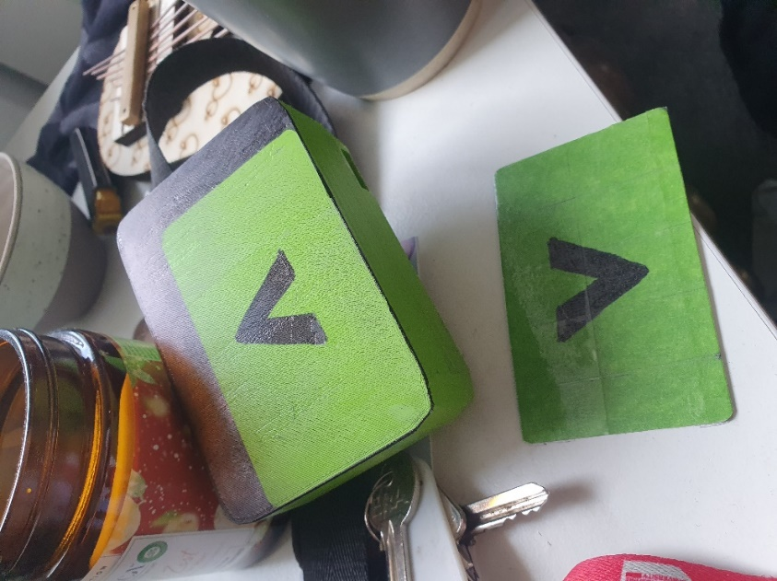

## Live testing & data collection

Live testing was informed by Geert De Meyer’s research paper (*De Meyer et al. Development and initial validation of a dog quality of life instrument’ - 2022*), which suggests studying physical, emotional and social aspects of dogs at several points in time to ensure the wellness and safety of any involved during the testing process. A survey comprised of 7-point Likert scales was created based on three quality of life domains (physical, emotional and social) mentioned in the paper. All information recorded during testing for this project is kept anonymous, with a false name assigned to each duo rather than taking their real names. This is to stay within the standards of GDPR regulations.

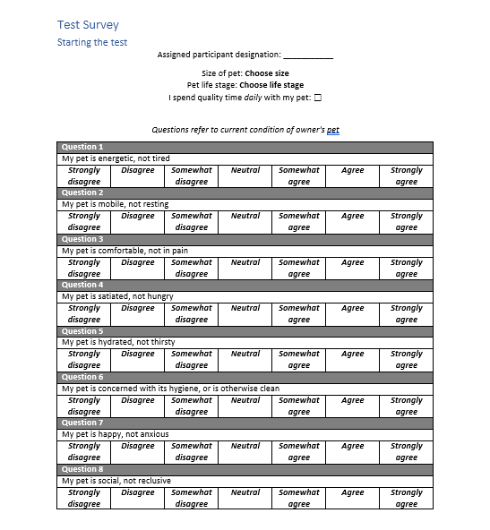

Testing is to begin with the form filled once by test participants to act as a baseline for any results. This allows to observe changes in the dog’s behaviors throughout testing. Unfortunately, due to wet weather during the window for live testing, this could not be conducted. As an alternative, the device was carried by the project researcher to obtain some results, though it should be noted that the survey was not filled out. The device was affixed at several points on the body and a similar walking route was taken to check if step data was accurate between the device and a Samsung Galaxy S10 phone using the Google Fit application.

|  |  |  |  |  |  |  |
| --- | --- | --- | --- | --- | --- | --- |
| ***Date*** | **5th May, 2023** | **6th May, 2023** | **7th May, 2023** | **8th May, 2023** | **8th May, 2023** | **8th May, 2023** |
| ***Participant Designation*** | Self-tested | Self-tested | Self-tested | Self-tested | Juice | Juice |
| ***Distance walked (km)*** | 0.9 | 0.9 | 2.2 | 1.0 | 0.015 | 0 |
| ***IMU Sensitivity*** | 50 | 50 | 50 | 50 | 50 | 50 |
| ***Steps recorded*** | 131 | 169 | 7 | 78 | 0 | 35 |
| ***Steps on Google Fit app*** | N/A | 1,308 | 2,473 | 1,409 | N/A | N/A |
| ***Device battery level*** | 4/4 | 4/4 | 4/4 | 4/4 | 4/4 | 4/4 |
| ***Notes*** | Attached to person's backpack | Stored in person's backpack, streak variable increments as expected | Attached on person's beltloop, device may have disconnected or been scanned more than once (causing step data to reset to 0 before scanning with the application), a bug was identified where the streak variable had reset back to zero | Stored in person's backpack, streak variable increments still set as 'Streak: 1' each day the application is used | Held in test participant's hand and walked around room. Device not sensitive enough, steps are only incremented with excessive force to device | Shaken in test participant's hand for approx. 5 seconds to ensure device was functional. It is confirmed that the application works on other Android devices. |
|  |  |  |  |  |  |  |
| ***Date*** | **9th May, 2023** | **10th May, 2023** | **10th May, 2023** | **11th May, 2023** | **12th May, 2023** | **12th May, 2023** |
| ***Participant Designation*** | Self-tested | Self-tested | Self-tested | Self-tested | Self-tested | Self-tested |
| ***Distance walked (km)*** | 1.06 | 1.0 | 0.96 | 1.2 | 0 | 0.95 |
| ***IMU Sensitivity*** | 50 | 50 | 25 | 1 | 1 | 25 |
| ***Steps recorded*** | 70 | 81 | 99 | 255 | 383 | 5554 |
| ***Steps on Google Fit app*** | 1,010 | 1,425 | 1,473 | 1,562 | N/A | 1,356 |
| ***Device battery level*** | 4/4 | 3/4 | 3/4 | 3/4 | N/A | 3/4 |
| ***Notes*** | Held in test participant's hand, streak variable increments still set as 'Streak: 1' each day the application is used | Stored in person's backpack, streak variable increments still set as 'Streak: 1' each day the application is used | Attached to person's backpack, device IMU sensitivity increased, steps tested via NXP TagInfo application. | Stored in person's backpack, streak increments bug fixed, sound trigger repetition bug persists. | Connected to Arduino IDE. Total steps variable was unsigned 8-bit and wrapped to 0 at 255. Now set to 32-bit. Will test again today. | Reading is far above Google Fit step data, IMU sensitivity should be decreased. Previous readings were incorrect due to uint8_t. |

Through testing the device, it was possible to check for quality-of-life issues and bugs in the device and application and fix them per each day. During early testing, it was found to be difficult to discern whether the device was powered on or off, so a piezo buzzer was fitted to sound a tone (*Arduino Reference – tone()*) on each powering on and use of the device.

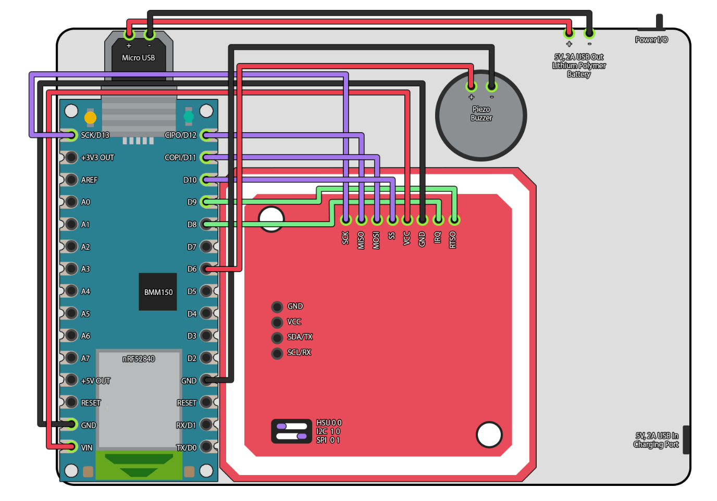  
*(Schematics of the corrected device, including the piezo buzzer)*

Either through faulty or poorly constructed components, the piezo buzzer’s sound was too quiet and muffled to be able to hear clearly. An LED should be used in later iterations of the device to make power flow and functionality obvious.

The battery used in live testing, a lithium polymer ‘power bank’ designed for the portable charging of mobile phones, was reduced by ¼ of its lifespan throughout the eight-day testing period. This suggests that it is a viable power source for the device going forward.

After the project concludes, updates will be made to the device casing to expose the internal LED to indicate power flow and the form factor will be dramatically decreased by fabricating a unique PCB board rather than rely on individual components.

## Conclusions / Reflection

To conclude the project, the scope and quality of the end outcome against the initial proposal will be contrasted.

Unity Android and Arduino was proposed for use in the duration of the project, which proved viable besides shortcomings such as scarcity of NFC tools or plugins. The open-endedness of a game engine like Unity (or potentially Godot) simplifies the process of creating these tools when compared to more close-ended engines like Unreal, which blocks experimentation while using Blueprints, but drastically increases complexity when using C++ instead. C# for Unity is an ample middle ground for experimentation and mobile development, as proven by Pokémon GO’s use of it for GPS tracking, networking and AR gameplay.

With no proper live testing undertaken, it is not possible to state whether the project can improve the relationship between a pet and their owner, though anecdotal evidence would suggest at least an interest in it. Additional features (Activity Log, photo mode, in-game guide) did not make it into the application due to time constraints and over-scoping early in development. Having experience with the project’s resources before undertaking a project like this and establishing a workflow beforehand would serve to speed up the entire process considerably. The insight into the project’s technologies will allow for improvements with the device and application when revisiting later.

Proposals for improvements of the project outcomes include replacing the current method of game data transferral via an NFC tag with HCE (Host Card Emulation) to store game data directly on the Android mobile phone. This will encourage users to stay closer to their pets while the device is used, as originally planned. Forcing vibrations in the mobile phone on scanning the device would also help in confirming a successful scan. A smaller casing device will be made possible once a PCB is fabricated to condense all component parts in a smaller area.

New application game modes, such as a ‘fetch’ timer and game leaderboard to track the test participant dog’s quickest times, among other statistics, would help to increase the longevity the project could receive in a commercial setting. The initial proposition of a full Activity Log feature to visualize game data in graphs and store photographs of walks taken with the associated dog alongside these could increase the application’s sentimental value, which is deemed by many pet owners to be an important quality (*Polygon – They're finally making a video game console just for dogs, 2023*).

Collated test results assisted in thorough QA testing, which will benefit future work on the project. The device’s IMU pedometer is currently too sensitive, but with adjustments can match with commercial pedometers such as the Google Fit application featured in modern Android devices. Waterproofing is essential to further testing, to prevent disruptions due to wet weather. This is the biggest shortcoming of the device, while the application suffered from a lack of depth in its features as previously discussed.

## Appendix

Development and initial validation of a dog quality of life instrument, Geert De Meyer, Amandine Schmutz, Nathaniel Spofford, Walter Burghardt (2022)  
<https://www.nature.com/articles/s41598-022-16315-y>

Guidelines for planning and conducting high-quality research and testing on animals:  
<https://labanimres.biomedcentral.com/articles/10.1186/s42826-020-00054-0>

PREPARE: guidelines for planning animal research and testing:  
<https://journals.sagepub.com/doi/10.1177/0023677217724823>

Analog Devices - Accelerometer and Gyroscopes Sensors: Operation, Sensing, and Applications, 2014  
<https://www.analog.com/en/technical-articles/accelerometer-and-gyroscopes-sensors-operation-sensing-and-applications.html>

## References

FitBit Developer - FitBit Studio  
<https://dev.fitbit.com/build/fitbit-studio>

Jon Gold, Network World – NFC vs. Bluetooth LE: When to use which  
<https://www.mocaplatform.com/blog/nfc-vs-bluetooth-low-energy-ble>

Iván González, Moca Marketing Blog - NFC VS BLUETOOTH LOW ENERGY (BLE)  
<https://www.mocaplatform.com/blog/nfc-vs-bluetooth-low-energy-ble>

Twisprite - Unity 3D Android NFC Plugin (GitHub)  
<https://github.com/twisprite-developers/unity-nfc-plugin>

Christophe Geske – Simple NFC app created with Unity (GitHub)  
<https://github.com/ChristophGeske/Near-Field-Communication-NFC-For-Unity-Android>

Unity Documentation – Android environment setup  
<https://docs.unity3d.com/Manual/android-sdksetup.html>

Unity Documentation – Manual: Android player settings  
<https://docs.unity3d.com/Manual/class-PlayerSettingsAndroid.html#Publishing>

Unity Documentation – Manual: Create a new keystore  
<https://docs.unity3d.com/Manual/android-keystore-create.html>

Unity Forum - ‘a failure occurred while executing com.android.build.gradle.internal.tasks.workers$actionfacade’  
<https://answers.unity.com/questions/1906770/a-failure-occurred-while-executing-comandroidbuild-1.html>

Tori Miller – Near Field Communication (NFC) For Unity Android (GitHub)  
<https://github.com/liswifi/NFC-For-Unity-Android-2021LTS>

Arduino Forum – Connecting the PN532 to Arduino Nano 33 Sense in SPI mode  
<https://forum.arduino.cc/t/connecting-the-pn532-to-arduino-nano-33-sense-in-spi-mode/1092978/3>

Unity Documentation – Script Serialization  
<https://docs.unity3d.com/Manual/script-Serialization.html>

Unity Documentation – Manual: Sprite Atlas Workflow  
<https://docs.unity3d.com/Manual/SpriteAtlasWorkflow.html>

Unity Documentation – Manual: Upgrading to Unity 2021 LTS  
<https://docs.unity3d.com/Manual/UpgradeGuide2021LTS.html#Android>

YouTube – Brackeys, SAVE & LOAD SYSTEM in Unity  
<https://www.youtube.com/watch?v=XOjd_qU2Ido>

Arduino – u-blox NINA B3 Series Datasheet  
<https://docs.arduino.cc/resources/datasheets/NINA-B3-series.pdf>

Arduino Store – Arduino Nano 33 BLE  
<https://store.arduino.cc/products/arduino-nano-33-ble>

Arduino Store – Arduino Nano 33 BLE Sense  
<https://store.arduino.cc/products/arduino-nano-33-ble-sense>

GitHub – Gerriko, Nano 33 BLE NFC Driver, 2022  
<https://github.com/arduino/ArduinoCore-mbed/issues/440>

Seeed - Nicho, RFID/NFC/MiFare chip selection guide  
<https://www.seeedstudio.com/blog/2020/05/29/which-is-best-rfid-nfc-mifare-chip-selection-guide-rc522-vs-pn532/>

Adafruit – PN532 NFC/RFID Controller Shield for Android + Extras  
<https://www.adafruit.com/product/789>

GitHub – Seeed, PN532, 2020  
<https://github.com/Seeed-Studio/PN532>

GitHub – Elechouse, PN532, 2018  
<https://github.com/elechouse/PN532>

Adafruit Learn – PN532 FAQ  
<https://learn.adafruit.com/adafruit-pn532-rfid-nfc/faq>

Adafruit Forums - Is it possible to use Adafruit PN532 NFC Shield to emulate, 2015  
<https://forums.adafruit.com/viewtopic.php?p=361176>

Arduino Docs – Nano 33 BLE Sense Rev2 Cheat Sheet  
<https://docs.arduino.cc/tutorials/nano-33-ble-sense-rev2/cheat-sheet#spi>

Codacy – Coding standards: what they are, and why do you need them, 2022  
<https://blog.codacy.com/coding-standards-what-are-they-and-why-do-you-need-them/>

GoToTags – NDEF Record Type  
<https://old.gototags.com/nfc/ndef/uri/>

GitHub – Arduino_BMI270_BMM150  
<https://github.com/arduino-libraries/Arduino_BMI270_BMM150>

Arduino Docs – Powering Alternatives for Arduino Boards  
<https://docs.arduino.cc/learn/electronics/power-pins>

Hubspot – What is UTF-8 Encoding?, 2021  
<https://blog.hubspot.com/website/what-is-utf-8>

Microsoft – Int32.TryParse Method  
<https://learn.microsoft.com/en-us/dotnet/api/system.int32.tryparse>

Electronics Hub – How To Power Arduino Nano With Battery  
<https://www.electronicshub.org/how-to-power-arduino-nano-with-battery/>

Biopak – What is PLA, 2022  
[https://www.biopak.com/uk/resources/what-is-pla](https://www.biopak.com/uk/resources/what-is-pla#:~:text=fuel%2Dderived%20hydrocarbons.-,Environmental%20advantages%20of%20PLA,and%20end%20up%20creating%20microplastics)

Texas Instruments - NFC Transponder datasheet  
<https://www.ti.com/lit/ds/symlink/rf430frl152h.pdf>

Hackaday – Reverse engineer a Pokéwalker  
<https://hackaday.com/2020/11/21/reverse-engineering-a-pokewalker/>

Ido Roseman - FreeStyle Libre Blood Glucose Monitoring System teardown  
<http://idoroseman.com/freestyle-libre-blood-glucose-monitoring-system-teardown/>

YouTube - Freestyle Libre Sensor Teardown and Inside Analysis  
<https://www.youtube.com/watch?v=sYIm97wjl0o>

GDC Vault – Using NFC with Android Applications  
<https://www.gdcvault.com/play/1019826/Using-NFC-with-Android>

All About Circuits – Read and Write on NFC Tags with an Arduino  
<https://www.allaboutcircuits.com/projects/read-and-write-on-nfc-tags-with-an-arduino/>

Unity Community – Read NFC tag from Unity3d android  
<https://answers.unity.com/questions/1341430/read-nfc-tag-from-unity3d-android.html>

Circuit Digest – DIY Arduino Pedometer, Counting Steps using Arduino and Accelerometer  
<https://circuitdigest.com/microcontroller-projects/diy-arduino-pedometer-counting-steps-using-arduino-and-accelerometer>

Android Authority – What is NFC and how does it work? Everything you need to know  
<https://www.androidauthority.com/what-is-nfc-270730/>

Developer.Android - NFC basics  
<https://developer.android.com/guide/topics/connectivity/nfc/nfc>

Developer Android - Sharing files with NFC  
<https://developer.android.com/training/beam-files>

Developer Android – Ndef  
<https://developer.android.com/reference/android/nfc/tech/Ndef>

GoToTags learn – NFC Data Exchange Format (NDEF)  
<https://learn.gototags.com/nfc/ndef#format>

Selecting Between I2C and SPI for Your Project  
<https://www.lifewire.com/selecting-between-i2c-and-spi-819003>

PN532 NFC RFID Module Tutorial | Interfacing PN532 with Arduino in UART, I2C & SPI  
<https://www.youtube.com/watch?v=PXE8nsXh4eg>

Modeelement14 Community – Trakcore, AI Assisted Posture Modification  
<https://community.element14.com/challenges-projects/design-challenges/design-for-a-cause-2021/b/blog/posts/trakcore-1-ai-assisted-posture-modification---project-introduction>

Measuring walking and running dynamics using skin mounted accelerometers  
<https://courses.physics.illinois.edu/phys398dlp/sp2019/documents/David_Surjo_p398_presentation.pdf>

Saucelabs – Getting Started with Manual & Live Testing  
<https://saucelabs.com/resources/blog/getting-started-with-manual-live-testing>

Hutscape – Display IMU data with LSM9DS1  
<https://hutscape.com/tutorials/nano33-ble-sense-imu>

Instructables – How to solder  
<https://www.instructables.com/How-to-solder/>

Accessing Accelerometer Data on Nano 33 BLE  
<https://docs.arduino.cc/tutorials/nano-33-ble/imu-accelerometer>

Polygon – They're finally making a video game console just for dogs (2023)  
<https://www.youtube.com/shorts/_13SBg-5LoA>

NXP – MiFare Q&A  
<https://www.mifare.net/wp-content/uploads/2015/03/MIFARE-QA.pdf>

Unity Answers – Open Google Maps with address in Unity, 2016  
<https://answers.unity.com/questions/1229489/open-google-maps-with-address-in-unity.html>

Unity Answers – Base64 encode/decoding?, 2010  
<https://answers.unity.com/questions/40568/base64-encodedecoding.html>

Microsoft Learn – C# Encoding.GetString Method  
<https://learn.microsoft.com/en-us/dotnet/api/system.text.encoding.getstring?view=net-7.0#system-text-encoding-getstring(system-byte()-system-int32-system-int32)>

Unity Forum - How to get system time in Unity?, 2009  
<https://forum.unity.com/threads/how-to-get-system-time-in-unity.29667/>

Microsoft Learn – C# DateTime.ToShortDateString Method  
<https://learn.microsoft.com/en-us/dotnet/api/system.datetime.toshortdatestring?view=net-8.0>

Stack Overflow – how get yesterday and tomorrow datetime in c#  
<https://stackoverflow.com/questions/8203900/how-get-yesterday-and-tomorrow-datetime-in-c-sharp>

Arduino Reference – tone()  
<https://reference.arduino.cc/reference/en/language/functions/advanced-io/tone/>

Arduino Reference – digitalWrite()  
<https://cdn.arduino.cc/reference/en/language/functions/digital-io/digitalwrite/>

Arduino Reference – pinMode()  
[https://www.arduino.cc/reference/en/language/functions/digital-io/pinmode/?_gl=1*laf09s*_ga*NTQzMTkzMTUxLjE2NzE0Njk5NDU.*_ga_NEXN8H46L5*MTY4MzIzNDQyMC43NC4xLjE2ODMyMzU5NDIuMC4wLjA](https://www.arduino.cc/reference/en/language/functions/digital-io/pinmode/?_gl=1*laf09s*_ga*NTQzMTkzMTUxLjE2NzE0Njk5NDU.*_ga_NEXN8H46L5*MTY4MzIzNDQyMC43NC4xLjE2ODMyMzU5NDIuMC4wLjA).